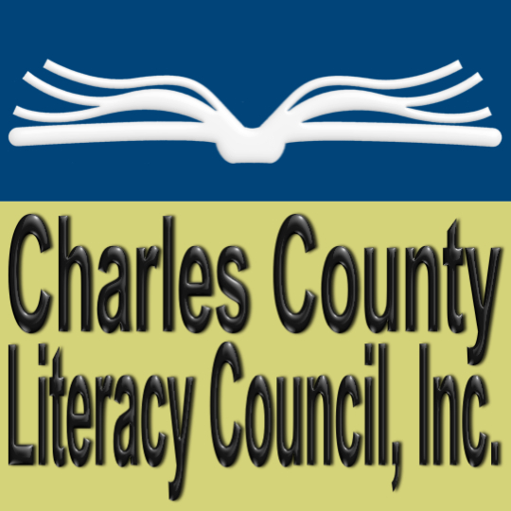

**Teaching Adults to Read**

**Make a gift today to support the Charles County Literacy Council in its mission of providing free community-based one-on-one adult literacy tutoring in the areas of reading, basic math, English for Speakers of Other Languages, preparation for GED and the military entrance exam, Armed Services Vocational Aptitude Battery (ASVAB).**

**Today’s Date: _______________________________**

**I’d like to make a gift of**

□ $25 □ $50 □ 100 □ $500` □ $1,000 □ Other $_______

**Donor Information:**

|  |  |  |  |
| --- | --- | --- | --- |
| Donor Name(s): | | | |
| Organization Name (if applicable): | | | |
| Street: | | | |
| City: | State: | | Zip: |
| Phone: | | *Email: | |

*By providing your email, you’ll receive occasional updates and newsletters from Charles County Literacy

Council (CCLC). You can unsubscribe at any time. CCLC will never rent, sell, or exchange your email address.

**Tribute Gifts:**  □ In honor of □ In memory of

|  |
| --- |
| Honoree Name(s); |
| Please Notify: |
| Address for Notification  (email or mailing): |
| Personal Message  (optional): |

**Mail completed form and check payable to Charles County Literacy Council to:**

Charles County Literacy Council, Inc., P. O. Box 2672, La Plata, MD 20646

**Any questions:** please contact Linda Heimpel, Program Coordinator, at 301-934-6488 or[**CharlesCountyLiteracy@comcast.net**](mailto:CharlesCountyLiteracy@comcast.net)